Title*: | Autonomous Network Slice Management for 5G Vertical Services
from Source*: | University Carlos III de Madrid
Contact: | Marco Gramaglia
input for Committee*: | ENI
Contribution For*: | Decision
 | Discussion | X
 | Information
Submission date*: | 2019-12-02
Meeting & Allocation: | ENI#12 -
Relevant WI(s), or deliverable(s):

ABSTRACT: This PoC shows how the adoption of the ENI principles and the integration with the ENI architecture can improve the strategies to build network slices for 5G Vertical Services. In particular, the ENI system will assist the entities in charge of Vertical Service Management and Network Slice Management in two major aspects:
1. Identify in an automatic manner the characteristics and profiles of 5G network slices to meet the requirements of vertical services, defined through an intent-based specification;
2. Manage composition, sharing and actions for the automated lifecycle of 5G network slices through enhanced, ENI-driven strategies based on service- and resource-level information.
This PoC has the ambition to showcase an end to 5G network that provides vertical services employing closed-loop automation through the usage of AI in all domains.

A.1 PoC Project Details
A.1.1 PoC Project
PoC Number (assigned by ETSI):
PoC Project Name: Autonomous Network Slice Management for 5G Vertical Services
PoC Project Host: TIM
Short Description: This PoC shows how the adoption of the ENI principles and the integration with the ENI architecture can improve the strategies to build network slices for 5G Vertical Services. In particular, the ENI system will assist the entities in charge of Vertical Service Management and Network Slice Management in two major aspects:
- identify in an automatic manner the characteristics and profiles of 5G network slices to meet the requirements of vertical services, defined through an intent-based specification;
- manage composition, sharing and actions for automated lifecycle of 5G network slices through enhanced, ENI-driven strategies based on service- and resource-level information.
This PoC has the ambition to showcase an end to 5G network that provides vertical services employing closed loop automation through the usage of AI in all domains.
A.1.2 PoC Team Members
Table A.1
 | Organization name | ISG ENI participant  (yes/no) | Contact (Email) | PoC Point of Contact  (see note 1) | Role (see note 2) | PoC Components
1 | TIM | Yes | luca.pesando@telecomitalia.it |  | Network operator | PoC Use Case definition
2 | Nextworks | Yes | g.carrozzo@nextworks.it | X | Other | Orchestration Framework
3 | Samsung | Yes | yue2.wang@samsung.com |  | Manufacturer | PoC Use Case definition
4 | WINGS | Yes | vfotein@wings-ict-solutions.eu  veras@wings-ict-solutions.eu  nellygiannopoulou@wings-ict-solutions.eu  vkosmatos@wings-ict-solutions.eu |  | Manufacturer | Performance Diagnostic
5 | UC3M | Yes | mgramagl@it.uc3m.es |  | Other | Intent-based algorithms
NOTE 1: Identify the PoC Point of Contact with an X.
NOTE 2: The Role will be network operator/service provider, infrastructure provider, application provider or other as given in the Definitions of ETSI Classes of membership.

All the PoC Team members listed above declare that the information in this proposal is conformant to their plans at this date and commit to inform ETSI timely in case of changes in the PoC Team, scope or timeline.
A.1.3 PoC Project Scope
A.1.3.1 PoC Goals
The PoC will demonstrate two use cases defined in ETSI GS ENI 001, as follows:
- Use case #2-8: Automatic service and resource design framework for cloud services. The PoC will extend the concepts of this use case from cloud services to 5G services, deployed across radio and transport, edge and cloud domains. The PoC will develop and validate a prototype that translates automatically the requirements of a Vertical Service, declared through an intent-based approach, into a resource-oriented definition of an end-to-end 5G network slice customized to host such service. The network slice description will cover not only the specification of the VMs hosting the VNFs of the service, as in the current Use Case, but also the network connectivity requirements in terms of virtual links capacity and QoS characteristics at the transport network level and the service profiles expected at the radio access segment. One of the characteristics of the proposed approach is to be highly context-dependent, that is, according to the network conditions at the moment of the onboarding, different orchestration strategies may be enforced. The overall target could be tuned according to different parameterizable functions that may favour, for instance, better resource utilization vs higher guarantees on the target QoE.
- Use case #3-2: Intelligent network slice management. The PoC will implement a prototype that will automate the management of the 5G network slices associated with multiple, concurrent Vertical Services. The prototype will embed algorithms, strategies and procedures for the composition, sharing and auto-scaling of network slice subnets to build and dynamically adjust the entire set of end-to-end network slices following a closed-loop approach. The objective is to meet the service-level requirements, while optimizing the usage of the underlying 5G infrastructure, jointly considering access, core, edge, cloud resources. Such strategies will be fed and assisted by the ENI system, based on short-term and long-term profiles related to resource availability, service and network slice performance, service demands, etc.
The assessment of the PoC, from a functional and non-functional point-of-view, will allow to verify the suitability of the ENI Reference Architecture ETSI GS ENI 005 to assist and enhance (i) the capabilities of the translation process between service and network slice requirements and (ii) the slice subnet composition/sharing strategies and the self-optimization procedures in the network slice management. The major functionalities of the ETSI ENI system to be validated in the context of this PoC are the following:
- Ingestion and normalization of multi-source, heterogeneous input data, related to service demands, service application performance, physical and virtual infrastructure utilization and NFV orchestration. All this data is originally collected by the monitoring systems adopted in the Vertical Service Manager, Network Slice Manager, NFV platform and NFV infrastructure. The data acquisition functionality will be implemented by the Data Ingestion functional block (ETSI GS ENI 005, clause 4.5.3.2.2) and the Normalization functional block (ETSI GS ENI 005, clause 4.5.3.2.3).
- Processing of input data to build a cross-domain knowledge about the trends of service demands, resource utilization, application and infrastructure performances and about how these elements are correlated. This functionality will be implemented by the Knowledge Management and Processing functional blocks (ETSI GS ENI 005, clause 4.5.3.3.1).
- Decision-making procedures, where the policies generated through the Policy Management functional block (ETSI GS ENI 005, clause 4.5.3.4.4) are used to assist, in the form of recommendations, (i) the algorithms for the translation between services and network slices, (ii) the algorithms for the composition of network slices and the control of the resources, and (iii) the logic controlling the automated lifecycle management of network slices for self-re-optimization purposes.
- Assessment of the system through the Performance Diagnostics component which will be part of the Situational awareness module (ETSI GS ENI 005, clause 4.5.3.4.2). The component will include functionalities for anomaly detection and root cause analysis (RCA) on the KPI measurements collected from the network infrastructure.
The PoC report will include a detailed description about how the functional blocks mentioned above have been adopted and implemented in the PoC, providing an analysis of their suitability and adaptation to the specific context of the PoC.
A.1.3.2 PoC Topics
Table A.2
PoC Topic Description | Related WI | Expected Contribution | Target Date
Use case 2.8 – Network Orchestration – Automatic service and resource design framework for cloud service  (ETSI GS ENI 001, clause 5.3.8) | ENI-005 (Architecture)  ENI-008 (Intent Aware Network Autonomicity) | Report on the adoption of ENI system to automate the translation between an intent-based Vertical Service definition and a Network Slice descriptor. | June 2020
Use case 3.2 – Intelligent Network Slice Management (ETSI GS ENI 001, clause 5.4.2) | ENI-005 (Architecture) | Report on the adoption of ENI system to enhance network slice management decisions for:  - Composition and sharing of network slice subnets for efficient provisioning of end-to-end 5G network slices for concurrent services.  - Automation of network slice scaling or migration procedures to adapt to multi-service dynamicity.  - use anomaly detection algorithms on network measurements to identify any low performance case in the network infrastructure  - use root cause analysis algorithms to identify the primary cause of low performance issues in the network | 1. July 2020  2. September 2020
Service and network requirements – General requirements – GR.1 and GR.2 (ETSI GS ENI 002, clause 5.2) | ENI-005 (Architecture) | Report on how the ENI system developed in the PoC:  - Use history data on service demands and network slice / service performances to learn and inject better translation strategies between intent-based service declaration and network slice resource-based descriptors.  - Use information about current as well as short-term and long-term trends of relevant context variables to build predictions of service demands and suggestions for automated network slice lifecycle actions. | 1. June 2020  2. September 2020
Service and network requirements – Service Orchestration and Management – SOM.2 and SOM.3 (ETSI GS ENI 002, clause 5.3) | ENI-005 (Architecture) | Report on how the ENI system developed in the PoC is adopted to:  - improve cross-layer decisions across three orchestration entities, i.e. Vertical Service Manager, Network Slice Manager and NFV Orchestrator, interacting in a closed-loop control model;  - provide suggestions to these three orchestration entities influencing their decisions, but without directly interacting with the elements under their control. | September 2020
Service and network requirements – Network planning and deployment – NDP.3, NDP.4, NDP.9 (ETSI GS ENI 002, clause 5.4) | ENI-005 (Architecture) | Report on how the ENI system developed in the PoC use the knowledge about virtual resource utilization in 5G infrastructures to compute and dynamically adjust an optimized set of network slices and network services to host concurrent vertical services with different characteristics and priorities. | September 2020
DCA requirements | ENI-009 (Data Mechanisms) | Report on the kind and characteristics (i.e., time granularity, update frequency) of the gathered data that will be used to provide the Intelligent Network Slice Management discussed above. | September 2020
DL requirements | ENI-009 (Data Mechanisms) | Report on the most suitable kind of learning algorithms that have to be adopted to provide closed loop network automation at all the network domain. For instance, the translation from intent to real orchestration decisions will be discussed along the lines of i.e., the kind of employed learning algorithm. | September 2020
Functional requirements – Interworking with other systems – IWOS.1 (ETSI GS ENI 002, clause 6.5) | ENI-005 (Architecture) | Specification of interfaces between ENI system and the three orchestration entities of the assisted system (Vertical Service Manager, Network Slice Manager and NFV Orchestrator) | March 2020
A.1.3.3 Other topics in scope
Table A.3
PoC Topic Description | Related WI | Expected Contribution | Target Date
Service and network requirements – Network optimization – NO.4 (ETSI GS ENI 002, clause 5.5) | ENI-005 (Architecture) | Report about the cooperation between the ENI system and assisted system to adapt dynamically the configuration of the network slices and network services to (i) the service demands and (ii) the resource utilization. | (i) July 2020  (ii) September 2020
Service and network requirements – Resilience and Reliability – RR.5 (ETSI GS ENI 002, clause 5.6) | ENI-005 (Architecture) | Report about the mechanisms adopted in the ENI system to build short-term and long-term profiles for the prediction of future service demands. | July 2020
Service and network requirements – Resilience and Reliability – RR.8 (ETSI GS ENI 002, clause 5.6) | ENI-005 (Architecture) | Report about the performance of the assisted system in the network slice management when taking automated, ENI-assisted decisions about the arbitration of services with different priorities. | July 2020

A.1.4 PoC Project Stages/Milestones
Table A.4
PoC Milestone | Stages/Milestone description | Target Date | Additional Info
P.S | PoC Project Start | January 2020
P.C1 | PoC Expected Contribution 1  Design of ENI system, assisted system, and interfaces | March 2020
P.C2 | PoC Expected Contribution 2  PoC implementation and documentation for ENI-assisted translation between intent-based vertical service declaration and network slice descriptor. | June 2020
P.D1 | PoC Demo 1  ENI-assisted translation between intent-based vertical service declaration and network slice descriptor. | June 2020 | Public demonstration at EuCNC 2020, June 15-18, Dubrovnik, Croatia
P.C3 | PoC Expected Contribution 3  PoC implementation and documentation for (i) ENI-assisted, service-driven network slice composition and sharing, and (ii) ENI-assisted, service-driven and automated network slice lifecycle management at service runtime. | September 2020
P.D2 | PoC Demo 2  ENI-assisted network slice composition, sharing and automation. | December2020 | ETSI ENI meeting or public event or scientific conference, still to be selected.
P.R | PoC Report | December 2020
P.E | PoC Project End | December 2020

A.1.5 Additional Details
None
A.2 PoC Technical Details
A.2.1 PoC Overview
The PoC will design, develop and validate an ENI-assisted system for the intelligent management of network slices in support of vertical services operating over 5G network infrastructures. The software prototype to be developed and demonstrated in the PoC will include the following entities:
- a reference implementation of the ENI System, compliant with the architecture defined in ETSI GS ENI 005. This implementation will include at least the functional elements for (i) ingestion and normalization of input data, (ii) knowledge management and processing, and (iii) policy management, which represent the three core functionalities of the ETSI ENI system to be validated in this PoC.
- a multi-layer ENI-assisted system, implemented as an extended NFV MANO platform, for the management of vertical services and network slices in 5G network infrastructures.
The Assisted System will interact with the ENI system to introduce novel or improved functionalities at its different layers. In particular, the ENI system will enable the automated translation of vertical service requirements, based on intent declarations, into network slice descriptors. Moreover, the ENI decision processes, based on heterogeneous cross-domain and cross-layer information, are expected to improve the efficiency of the network slice management strategies. In this context, multiple ENI outcomes are expected to feed the Assisted System orchestration entities in the form of policies or suggested commands, enabling (i) more efficient decisions about slice composition and sharing, as well as (ii) self-triggered lifecycle management actions for dynamic and context-aware slice and network service adjustment.
The PoC will demonstrate the advanced capabilities of the ENI-assisted system applied to multiple 5G Vertical Services, with different QoS requirements, traffic profiles and service priorities, operating concurrently over a shared and multi-domain 5G infrastructure, integrating radio, transport, edge and cloud resources. Target Vertical Services will include virtual reality or multimedia high quality production , as representative of enhanced Mobile BroadBand (eMBB) and ultra-Reliable and Low Latency Communication (uRLLC) service categories. In particular, the demonstrations will show:
- How the ENI-driven service-to-slice translation mechanism will be able to extract the service requirements from the user intent, mapping them into network slice profiles for eMBB and uRLLC network slices. Exploiting historical information about service performance versus slice characteristics, the system will improve the translation decisions to provide better matches between the network slice resources (e.g. capabilities of network links, capacity of VMs, etc.) and the service requirements.
- How the network slice provisioning strategies, assisted by the ENI system, will improve the utilization of the 5G infrastructure through the composition, sharing and re-usage of network slice subnets into coexisting end-to-end network slices.
- How the ENI system will provide mechanisms for the self-optimization of network slices and NFV network services, suggesting self-triggered actions to continuously adjust the slices configuration not only according to the real-time resource utilization and service demands, but also taking into account predictions for future service requests.

A.2.2 PoC Architecture
The Assisted System to be implemented in the PoC includes three main functional entities, cooperating together at different layers for the orchestration of 5G network slices customized according to the vertical service requirements. As shown in Figure 1, the Assisted System components that will directly benefit from the ENI services will operate at the Service Layer and at the SDO Layer respectively. At the Service Layer, the Vertical Service Manager (VSM) will manage the lifecycle of vertical services, delegating the operation of service-driven network slices to the underlying Network Slice Manager (NSM), which operates at the SDO Layer. The NSM is responsible for the lifecycle management of the end-to-end network slices hosting the services. In turn, these network slices are built using NFV network services, which are handled by the NFV Orchestrator (NFVO), also operating at the SDO Layer.
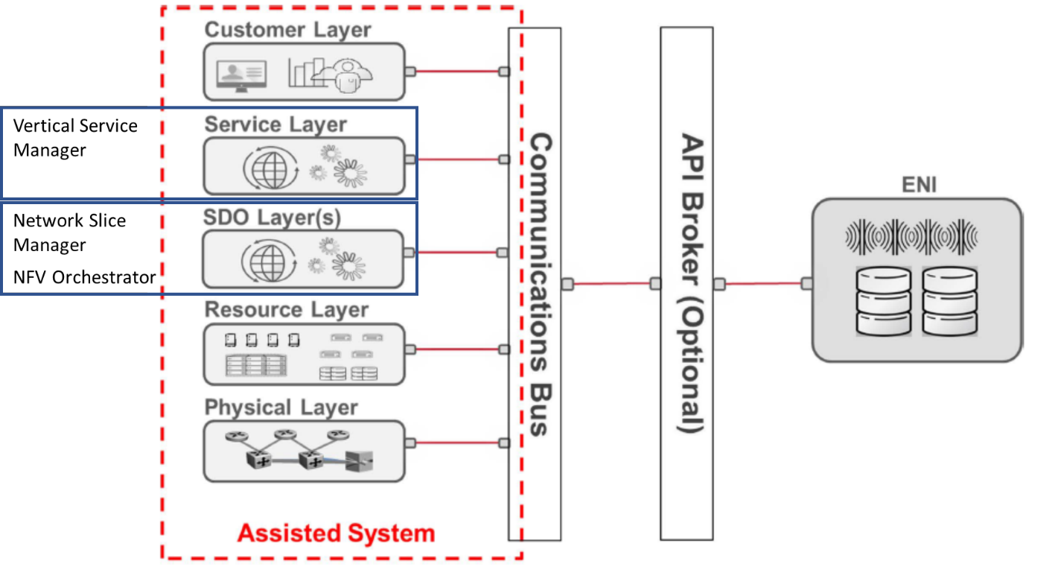
Figure 1 – Positioning of the PoC systems in the ENI framework
The high-level architecture of the Assisted System proposed in the PoC is shown in Figure 2. The picture highlights the bi-directional interactions between Assisted System and ENI System, which implement the closed-loop monitoring/re-configuration process for the continuous re-optimization of the network slices. The adoption of the API broker is foreseen to mediate and facilitate the communication between the Assisted and ENI systems.
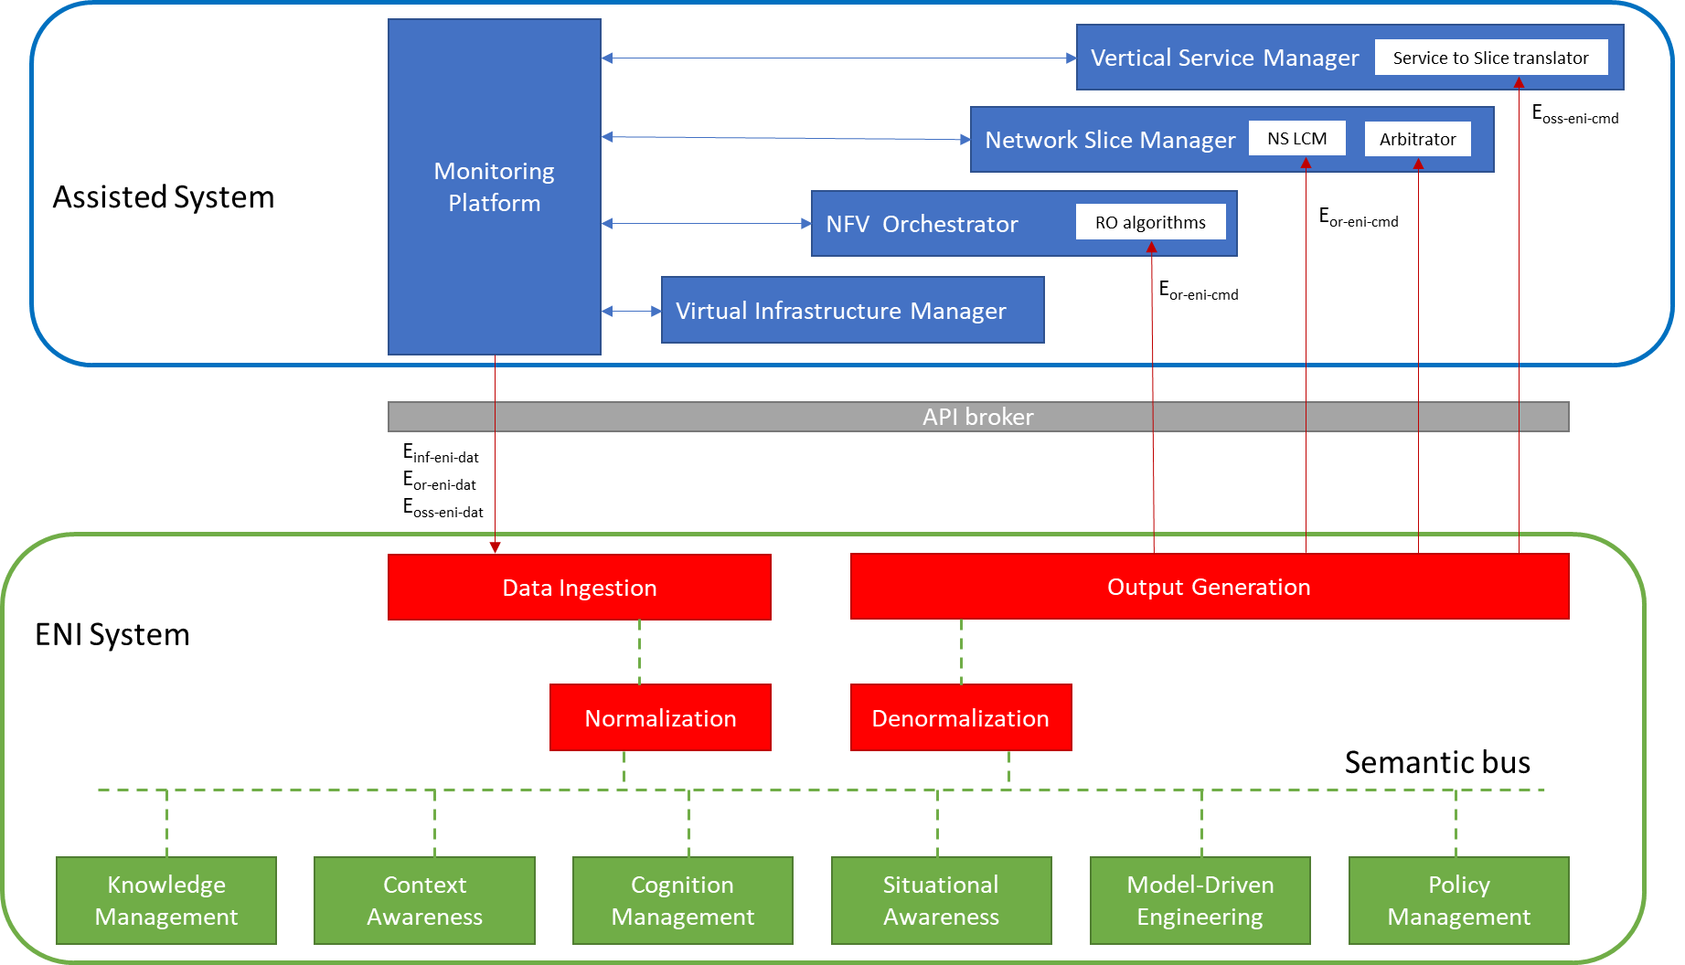
Figure 2 – High-level PoC architecture and interactions between Assisted System and ENI System
The Assisted System includes the following elements:
- A Vertical Service Manager (VSM) handling the Vertical’s requests instantiation, operation and termination of vertical services. Vertical service requests are expressed through intent declarations and they are mapped into network slice descriptors through the “Service to Slice translator” internal component. The current implementation of the VSM translator is based on the manual configuration of static translation rules acting as policies. In the PoC, the interaction with the ENI system will allow to dynamically update such policies regulating the translation process to better fit the service requirements.
- A Network Slice Manager (NSM) responsible for the provisioning and management of the end-to-end network slices. The NSM includes two internal modules, the Network Slice LifeCycle Manager (NS LCM) and the Arbitrator. The NS LCM coordinates the lifecycle actions to operate the network slices, e.g. their up/down-scaling, migration, re-configuration or termination. The Arbitrator provides the logic to build the end-to-end network slices through the composition of atomic network slice subnets, which can be shared and re-sized according to the slice requirements and service priorities. The Arbitrator also manages the concurrency of multiple network slice instances competing for the shared infrastructure resources or for the resource quotas assigned to the given tenants. In the PoC, the ENI system will provide input to the NS LCM suggesting commands for the automated re-optimization of the whole set of network slices, based on short- and long-term predictions on service demands and infrastructure utilization. Moreover, the ENI system will update the policies regulating the Arbitrator algorithms, improving the strategies for slice subnets sharing and end-to-end slice composition.
- An NFV Orchestrator (NFVO) managing the NFV Network Services composing the Network Slices. The ENI system will provide feedback to the Resource Orchestrator (RO) algorithms of the NFVO, in charge of VNF placement decisions, triggering automated migration procedures to improve the infrastructure utilization.
- A Virtual Infrastructure Manager (VIM) for the management of the 5G infrastructure. In the PoC, the traditional VIM will include mechanisms for the control of edge and core resources and it will be integrated with SDN controllers and radio orchestrators for the management of the transport and radio network. The VIM will not interact directly with the ENI system, but it will actuate the “commands” received by the NFVO for the allocation of VNFs, the setup of transport network paths and the configuration of the radio channel. Moreover, it will act as a source of monitoring data related to physical and virtual resources.
- A cross-layer Monitoring Platform, that will collect monitoring data from VSM, NSM, NFVO and VIM. This monitoring data will be provided as input to the Data Ingestion component of the ENI system and will include information related to service demands, application/service performance, virtual resource utilization and physical infrastructure load. The monitoring data will constitute the basis to build the cross-domain/cross-layer knowledge at the ENI system and feed its decision-making procedures.
- A performance diagnostics module, that will retrieve network performance measurement data (e.g. measurement data for selected KPIs) from the Monitoring Platform (via the API broker) and will provide recommendations to the network orchestrator (again via the API broker).
A.2.3 PoC Success Criteria
The PoC validation will assess the correct workflows of the system from a functional point of view, verifying the interactions between the different components of the system and their internal functionalities. Moreover, the validation procedures will compare the performance of the Assisted System when working in stand-alone mode and in ENI-assisted mode, thus proving the enhancement of the overall performance in the latter mode. The validation will be performed running the system with two different categories of services, with eMBB and uRLLC network slices.
The specific Key Performance Indicators that will be considered for each of the goals targeted in the PoC are detailed in Table A.5, specifying the operational characteristics of the relevant components in the stand-alone and ENI-assisted modes respectively.
Table A.5: KPIs for PoC validation
Goal to be verified | KPI | Stand-alone mode | ENI-assisted mode
Translation between intent-based Vertical Service definition and resource-based descriptor of the end-to-end 5G network slice. | Service performance (see note 1) | Translation based on static rules preconfigured by the system administrator. | Translation rules dynamically modified through policies injected by the ENI system, according to historical data about relationships between network slice characteristics and service performance.
Enhanced strategies for sharing and composition of network slices. | Utilization of the 5G infrastructure.  Total amount of resources used by the global set of network slices, for radio, transport, edge and core computing resources.  Service performance (see note 1). | Static rules for network slice composition and sharing, applied at the provisioning time only and based on the current resource utilization and the currently active network slices. | Slice composition and sharing rules are dynamically modified through policies injected by the ENI system, according to short-term and long-term predictions for future service demands.
Automation of scaling and migration procedures for self-re-optimization of the global set of network slices. | Utilization of the 5G infrastructure.  Total amount of resources used by the global set of network slices, for radio, transport, edge and core computing resources.  Service performance (see note 1). | Feature not supported. Network slices are scaled manually or automatically, based on the real-time performance of single services following a threshold-based mechanism. | Suggested commands for network slice re-optimization are triggered from the ENI system, according to cross-layer and cross-domain monitoring data feeding a decisions process related to the entire set of network slices.
Note 1: Service performance will be measured through application-based KPIs, to be defined for each of the services adopted in the PoC.

A.2.4 Additional information
None.

