Title*: | ZSM003 clarify network slice as a service
from Source*: | Nokia Germany, Telefónica S.A., Deutsche Telekom AG, Huawei
Contact: | Jing Ping, Jose Ordonez-Lucena, Michael Klotz, Zou Lan
input for Committee*: | ZSM
Contribution For*: | Decision | X
 | Discussion
 | Information
Submission date*: | 2021-01-07
Meeting & Allocation: | ZSM#14-e -
Relevant WI(s), or deliverable(s): | DGS/ZSM-003ed111_Slicing

Decision/action requested: Please approve

ABSTRACT:

4.3.2 Using “Network Slices as NOP internals”
In the "Network Slices as NOP internals" scenario, one entity takes both CSP and NOP roles and provides the communication service to vertical customer. The network slice instances are not visible to CSCs (example: verticals). The entity decides whether network slices instances or the network is used to support the communication services (e.g. for internal network resource utilization consideration etc.). This scenario allows the vertical consumer (CSC) to use the communication service and optionally allows vertical to monitor the network status of the network that supports the communication service.
Figure 4.3.2-1 quoted from 3GPP (see [4]) illustrates an example on how network slices can be utilized to deliver communication services based on the 3GPP defined roles:

DN
NF
NF
Network Slice
Network view
Management view
CSP
NOP

CSC
NSI
CS
offer
a)
Figure 4.3.2-1: 3GPP example of Network Slice as NOP internals
Figure 4.3.2-2 illustrates an example on how network slices from business view can be utilized to deliver communication services in ZSM:
A network slice composes group of NFs. One business entity (X) takes the role of both NOP and CSP delivers communication services to vertical customer. Only communication service is exposed to the vertical customer. The vertical should be able to monitor the communication service status (e.g. administrative status, operational status, etc.) and performance data via the exposed interfaces
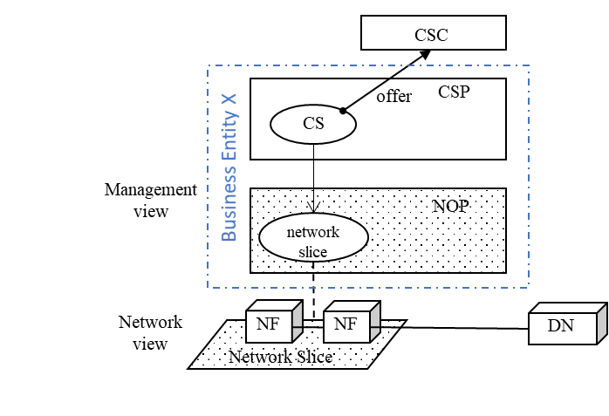
Figure 4.3.2-2: ZSM example of Network Slice as NOP internals

4.3.3 Adopting “Network Slices as a Service” model
In the "Network Slice as a Service" scenario, network slice can be offered to vertical as a service. This scenario allows vertical to use the network slice and optionally allows vertical to manage the network slice via management exposure interface. In addition, vertical can offer their own services (e.g. communication services) that rely on the new network slice.
Figure 4.3.3-1 quoted from 3GPP (see [4]) illustrates an example on how network slices can be utilized to deliver communication services, including Network Slice as a Service reusing the 3GPP defined roles:

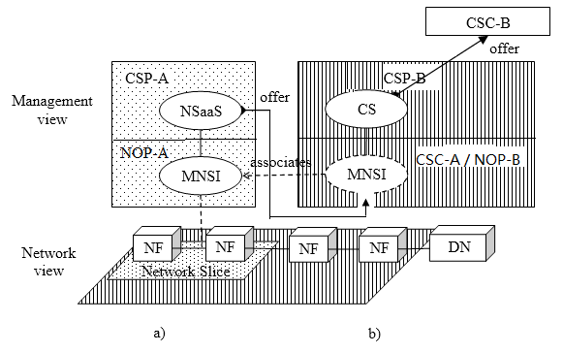
NSI
NSI
Figure 4.3.3-1: 3GPP example of Network Slice as a Service being utilized to deliver communication services to customers

Figure 4.3.3-2 illustrates an example on how network slices from a business view can be utilized to deliver communication services in ZSM.
In this example, CSP uses the network slice offered by NOP and its own network functions to deliver Communication Services to customers (CSC). CSP and NOP are different business entities (X and Y) in this example.

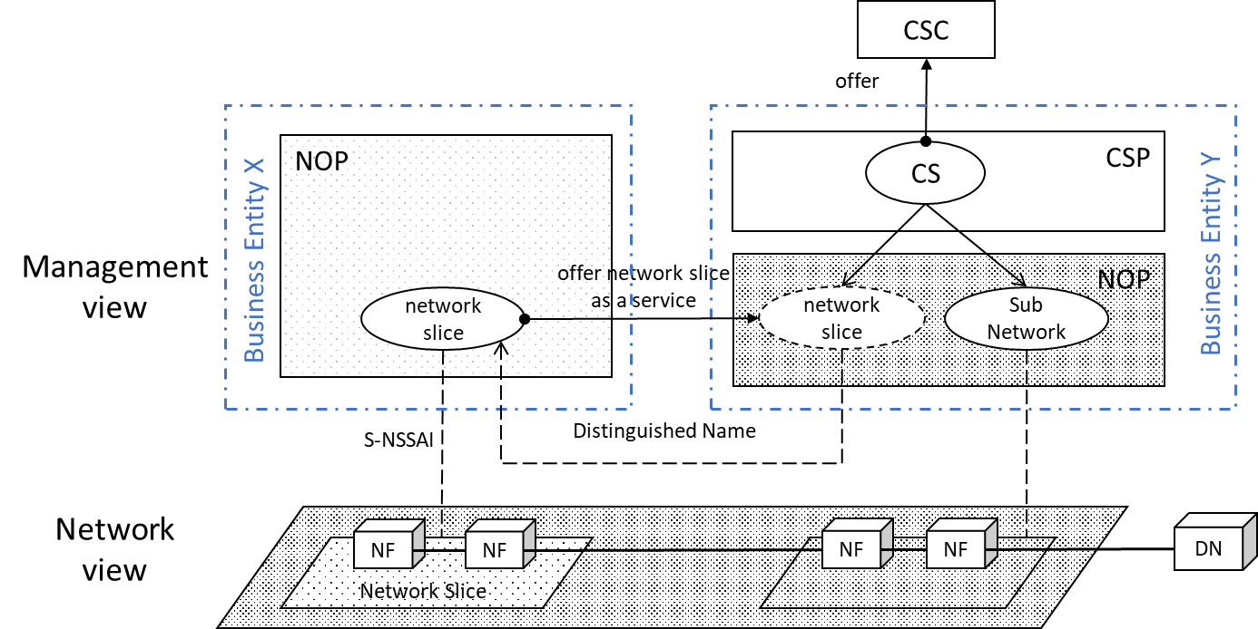
Figure 4.3.3-2: ZSM example of Network Slice as a Service being utilized to deliver communication services to customers
NOTE: network slice shown in left side of the figure is a managed object instance created by NOP of Business Entity X. It is offered as network slice as service to Business Entity Y as network slice shown in the right side of the figure. CSP of Business Entity Y uses Distinguished Name to refer to and access the network slice created in the NOP.
NOTE: Depending on the use case, the business entity Y could represent a vertical customer or another MNO.

In another example, as shown in Figure 4.3.3-3 , CSP of Business Entity Y may use the network slice offered by NOP of Business Entity X and additional network functions to build a new network slice.
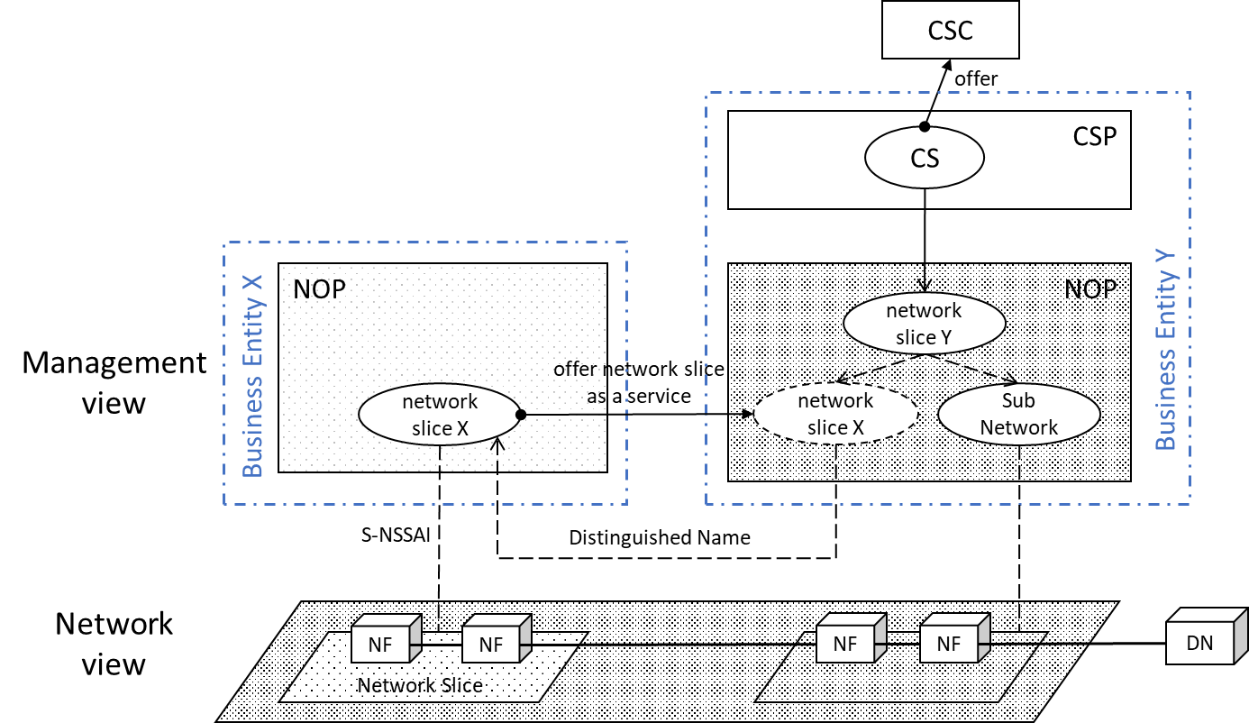
Figure 4.3.3-3: ZSM example of Network Slice as a Service being utilized to build a new network slice

